Introduction:

Usability refers to the capability of a system to be usable. Generally, it means the way a system can interact with the users to provide user’s immediate needs and context. This definition generates from the idea of the human behaviour and psychology. Humans by nature crave comfort and want to achieve any amount of success in any work with the bare minimalistic effort and the same applies while designing an interface. One of the key factors of usability is to optimize the user experience that is designing website in such a way that it encourages effective and efficient human-computer interactions . If a system is easy to use and completes any task of the user with low effort and no errors then a system is said to be usable.

While designing a web interface, the designers need to consider the main objective of usability i.e. focusing on reducing the user’s workload by making the use of the system’s abilities. The design should strive for simplicity, aesthetically pleasing, accessible and it should maintain clarity while ensuring the goals of the website. If the website application is hard to navigate and users lose their track due to a cluttered design, it might be frustrating for the users which can affect the overall success of the web application.

Literature Review:

A successful web interface design on user interface (UI) and user experience (UX) depends on usability. To design an interface that is both easy to navigate and user-friendly, it should include navigation bars with predictable patterns, allowing users to effortlessly move through features without confusion. The interface design should be minimalistic to reduce clutter and should be visually appealing, making it intuitive. Consistency in design elements and their placement develops user familiarity , which can help in navigation. These principles not only help minimize human effort for successful completion of tasks but also creates an environment for users to feel comfortable and engaged. Additionally, prioritizing accessibility and inclusivity by maintaining the standard like the Web Content Accessibility Guidelines(WCAG) ensures that all the (Mazumder & Das, 2014)

For designing any kind of interface, there are laws that need to be implemented for enhancing usability and those laws include Schneiderman’s eight golden rules and Jacob Neilson’s 10 usability heuristics. Those rules are key to boosting usability in interface design and some of those include ensuring consistency across the interface to help users with navigation and become familiar with the system. Introducing shortcuts can significantly speed up task execution for frequent users. It's also important to provide instant feedback for actions to avoid user confusion and frustration. Informative dialogs that indicate the success or failure of tasks are crucial for clear communication. Error handling should be straightforward, offering solutions that help users correct mistakes without hassle. Allowing users to easily reverse actions enhances usability by making the interface more forgiving. The system should be designed to make users feel in control, promoting an internal locus of control rather than feeling controlled by the system. Lastly, reducing the need for users to rely on short-term memory by designing an intuitive interface reduces cognitive burden, creating a more enjoyable user experience. These guidelines work together to make interfaces that are efficient, (Leavitt & Shneiderman, 2015)

Two products based on web design interfaces:



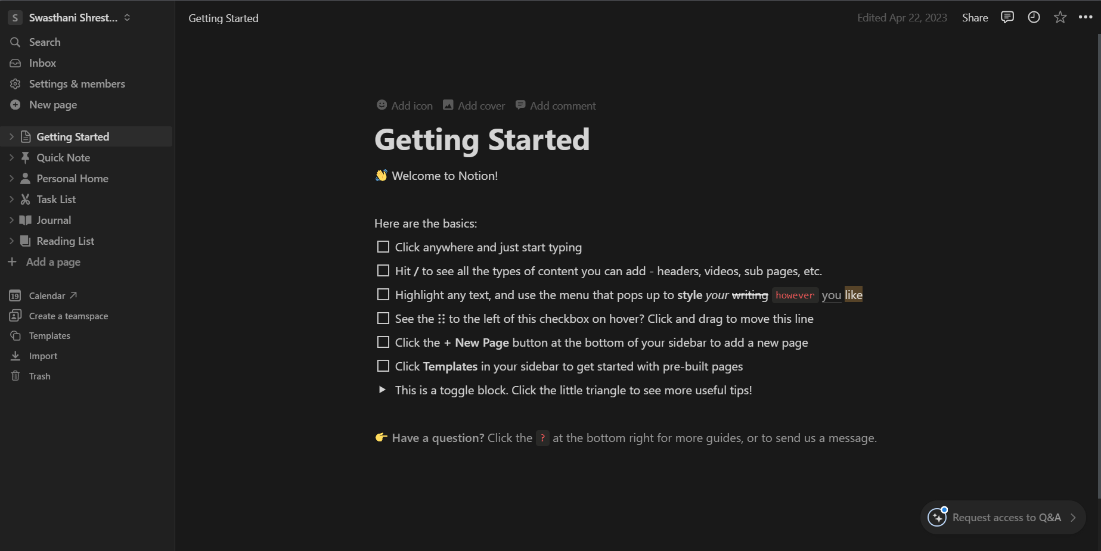

# Bibliography

Leavitt, M. O., & Shneiderman, B. (2015). *Based web design & usability guidelines.* Retrieved from https://d1wqtxts1xzle7.cloudfront.net/57528614/guidelines_book-libre.pdf?1539034689=&response-content-disposition=inline%3B+filename%3DResearch_Based_Web_Design_and_Usability.pdf&Expires=1710869439&Signature=gfJ90Ha8ec3UamwhhqB3Fx2ivqTN71Ods2U9aOqt~LLfsCh

Mazumder, F. K., & Das, U. K. (2014). *USABILITY GUIDELINES FOR USABLE USER INTERFACE.* Dhaka: International Journal of Research in Engineering and Technology.